June 9, 2023

Suna jAYYOUSI

Pillow Palooza

**NYC Short-Term Rental**

data analysis

Introduction

Pillow Palooza is a start-up focused on disrupting the traditional real estate market by offering short-term rental options for travelers. The company has seen a significant increase in demand for short-term rentals in New York City, but wants to better understand the market in order to optimize their business strategy.

Pillow Palooza has collected data from various sources on Airbnb listings in New York City to gain insight into the market. The company now plans to analyze this data using its internal teams, in order to provide recommendations on how to maximize revenue and occupancy rates for their short-term rental properties.

Analysis

# Step #1: Data Wrangling and Cleaning

This initial cleaning and preparation step is critical to ensure that the data is reliable and accurate. It also sets the foundation for the subsequent steps in the analysis, which will involve identifying trends in the NYC Airbnb market.

# Step #2: Data Insights with SQL

In this part we used cleaned data set to answer few questions by sql

**Q1)**

**What is the most common room type in NYC Airbnb listings?**

**Answer:** Entire home/apt

**Code:**

Select count(*),

room_type

from room_types

group by room_type

**Q2)What is the average price of a listing by room type?**

**Answer:** shared room 53.647

entire home/apt 197

private room 81.674

**Code:**

SELECT room_type,

Avg(price)

FROM room_types

JOIN prices using(listing_id)

GROUP BY room_type

**Q3)Which borough has the highest average price per month?**

**Answer:** manhattan 5596.687

**Code:** SELECT borough,

Avg(price_per_month)

FROM prices

GROUP BY 1

ORDER BY 2 DESC

**Q4) How many listings of each room type are in each borough?**

**Answer:**

|  |  |  |
| --- | --- | --- |
| borough | count | room_type |
| Manhattan | 6170 | entire home/apt |
| Staten Island | 133 | entire home/apt |
| Queens | 1335 | entire home/apt |
| Brooklyn | 5367 | entire home/apt |
| Bronx | 261 | entire home/apt |
| Queens | 2009 | private room |
| Manhattan | 3901 | private room |
| Brooklyn | 4906 | private room |
| Bronx | 403 | private room |
| Staten Island | 132 | private room |
| Bronx | 33 | shared room |
| Brooklyn | 187 | shared room |
| Manhattan | 251 | shared room |
| Staten Island | 2 | shared room |
| Queens | 112 | shared room |

**Code:** SELECT borough,

Count(room_type),

room_type

FROM prices

JOIN room_types using(listing_id)

GROUP BY 1,

3

ORDER BY 3

**Q5) How many listings in each room type category have a price of over $500 per night?**

**Answer:** shared room 1

entire home 395

private room 19

**code:**

SELECT Count(listing_id),

room_type

FROM prices

JOIN room_types using(listing_id)

WHERE price > 500

GROUP BY 2

**Q6) What is the distribution of listing prices by neighborhood?**

**Answer:**

|  |  |  |  |
| --- | --- | --- | --- |
| borough | min | max | avg |
| Queens | 10 | 2600 | 92.81394676 |
| Brooklyn | 10 | 7500 | 121.9746654 |
| Staten Island | 13 | 300 | 86.04494382 |
| Manhattan | 10 | 5100 | 184.0006782 |
| Bronx | 20 | 670 | 79.241033 |

**Code:** SELECT borough,

Min(price),

Max(price),

Avg(price)

FROM prices

GROUP BY 1

**Q7) What is the estimated amount of revenue generated by hosts in each borough?**

**Answer:**

|  |  |
| --- | --- |
| borough | sum |
| Queens | 58404083 |
| Brooklyn | 279130240 |
| Staten Island | 3443919 |
| Manhattan | 393420567 |
| Bronx | 9324180 |

**Code:** SELECT borough,

Sum(price * booked_days_365)

FROM prices

JOIN reviews using(listing_id)

GROUP BY 1

**Q8)What is the average price per month for listings in each neighborhood?**

**Code:**SELECT neighbourhood,

Avg(price_per_month)

FROM prices

GROUP BY 1

**Q9)How many listings have no reviews?**

**Answer:**0

**Code:**SELECT Count(listing_id)

FROM prices AS p

WHERE NOT EXISTS (SELECT 1

FROM reviews r

WHERE p.listing_id = r.listing_id)

**Q10)How do the estimated book days correlate with the price of an Airbnb listing in New York City?**

**Code:**SELECT Corr(price, booked_days_365)

FROM prices

JOIN reviews using(listing_id)

# Step #3: Presenting your findings

In this part I used tableau to present my findings and insights

This the link for my dashboards:

<https://public.tableau.com/app/profile/suna.jayyousi/viz/suna121234/Dashboard1?publish=yes>

1. What are the most popular neighborhoods for short-term rentals in New York City?

I answered this question by filter the data by borough and then obtain the most popular neighborhoods in each borough

Mott heaven in Bronx 46 listings, Bedford in Brooklyn with 2206 listings ,Harlem in Manhattan 1435 listings ,Astoria in queens with 448 listings, Tompkinsville in staten island 33 listings.

1. What is the average rental price for short-term rentals in New York City, and how does it vary by neighborhood and property type?

Open the link of tableau, and filter this graph by room type

**Room type: entire home/apt**

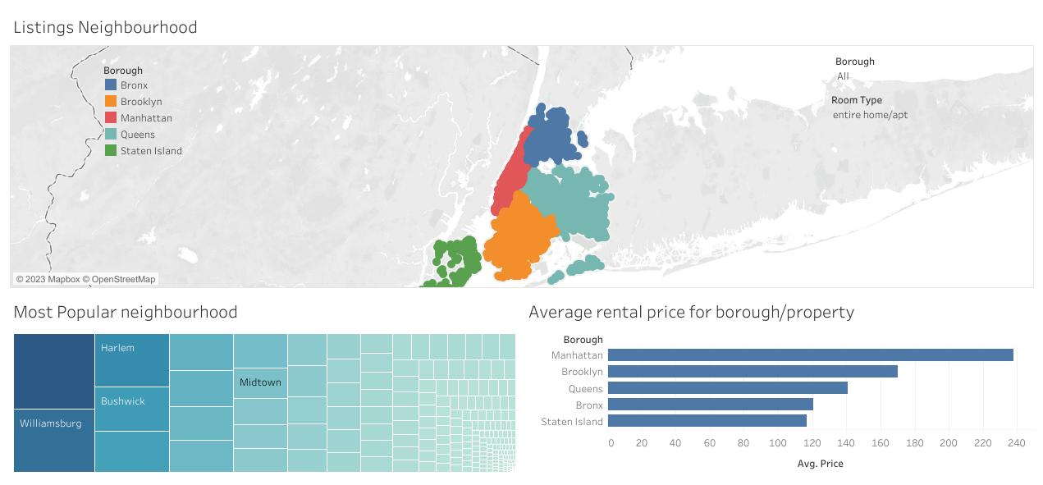

**Room type: private room**

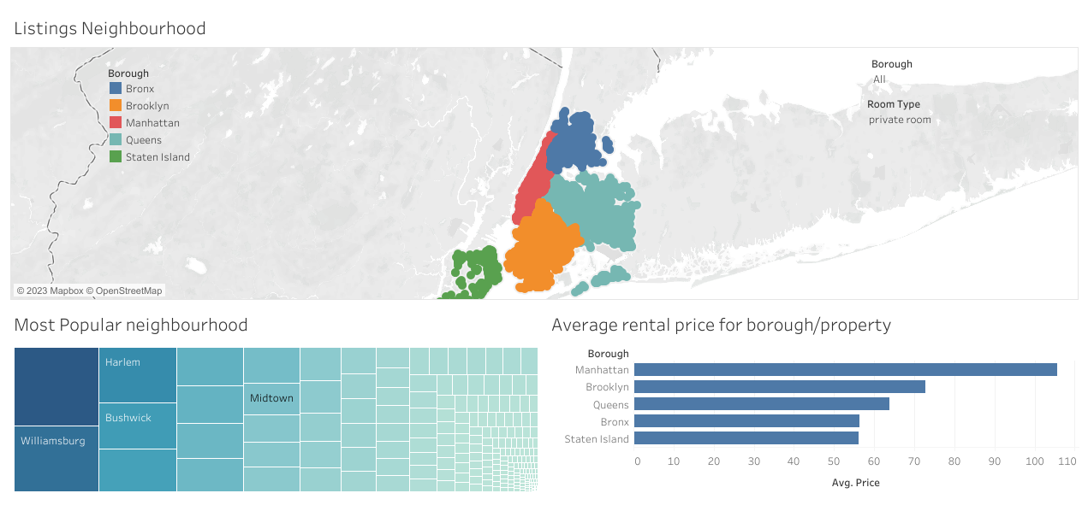

**Room type: shared room**

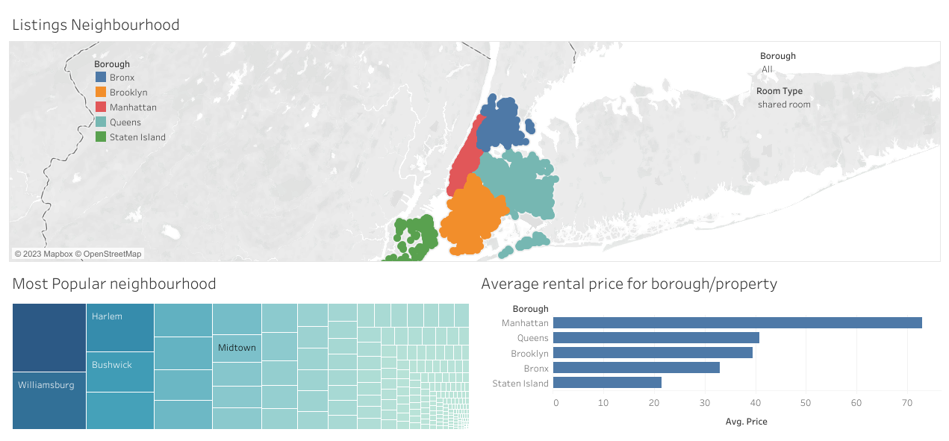

1. What are the most commonly rented property types on Airbnb in New York City, and how does this vary by neighborhood?

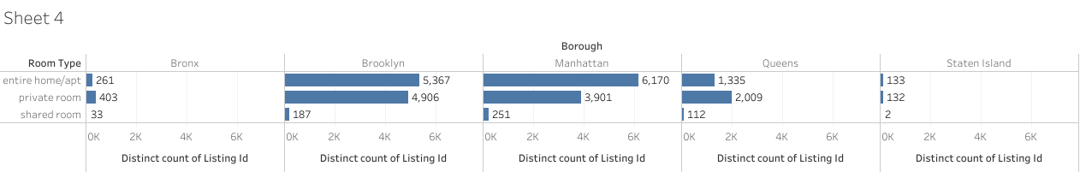

1. What is the average length of stay for short-term rentals in New York City, and how does this vary by neighborhood and property type?

We don’t have data about length of stay

1. How has demand for short-term rentals in New York City changed over time, and are there any seasonal trends that could impact business decisions?

We don’t have enough data

Recommendations

1. Most popular property type is home entire then private room, so we recommend company to focus on this two type to increase revenue.
2. Manhattan and Brooklyn are the most popular borough short rental property, we recommend to focus on this places to increase revenue.
3. Queens has a less avg rental price for all property type, so we can make offer for customers to rent there and also we can gain more revenue.